OFFICE OF THE CHANCELLOR
206 Parker Hall 300 West 13th Street
Rolla, MO 65409-0910
Phone: 573.341.4114
Fax: 573.341.6306
chancellor@mst.edu

LETTER OF PROMULGATION

Missouri University of Science and Technology is committed to protecting the well-being of the campus community as well as its property and facilities. To help ensure that we as a campus are as prepared as we can be to protect the campus in the event of a serious threat, hazard or emergency situation, the Missouri S&T Emergency Operations Committee has developed the following emergency management plan.

No plan can completely prevent the consequences of an incident, whether to property or to life. However, good plans executed by knowledgeable and well-trained personnel can and will minimize losses. This plan establishes the organization, chain of command, specific policies and general procedures that should be followed by all Missouri S&T students, faculty and staff in the event of an emergency, and is designed to help university employees respond appropriately when emergency conditions arise. Although these situations are unpredictable, this plan allows for an immediate response by university employees, thereby minimizing danger to our campus.

I urge every member of the Missouri S&T community to read this plan and understand his or her role in emergency situations. Please review this manual so you can support your colleagues and protect our students, faculty, staff and visitors should an emergency or threat arise.
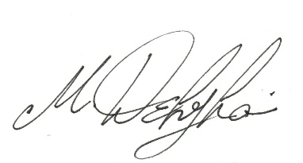
Best regards,

Mohammad Dehghani, Ph.D.
Chancellor

RECORD of CHANGES
Contact(s) | Date of Change | Revision No. | Section | Summary of Change
Christy Laughlin | 08/15/2014 | 1 | 5.1 | Removal of steam whistle as part of alert system.
Raymon Bogart | 06/30/2015 | 2 | 3.1, 3.2,  4.1, 7.0 | Updated titles and contact information
Raymon Bogart | 8/20/2015 | 3 | 3.1, 3.2 | Added IT Dept., updated titles, and contact information
Doug  Roberts | 06/28/16 | 4 | 7.0 | Added Chief Doug Roberts to  list of people with copies.
Doug  Roberts | 06/29/17 | 5 | 7.0 | Removed Chancellor Cheryl Schrader and added Interim Chancellor Christopher Maples
Doug  Roberts | 06/29/17 | 5 | 5.8.5 | Removed the radio station.  KMST and the document: Response Procedures for Emergencies
Doug  Roberts | 07/06/17 | 6 | 3.1.3, 3.2  4.5 | Amended titles and positions.  New map and legend
Doug  Roberts | 07/12/18 | 7 | 5.1.2 – 5.12.2 | Added verbiage related to the concept of Run-Hide-Fight
Doug  Roberts | 07/31/18 | 8 | 7.0 | Removed Warren Wray, added Interim Vice Chancellor Cuba Plain, removed Shenethia Manual, and removed Elizabeth Smith
Doug  Roberts | 08/01/19 | 9 | 3.2.1, 3.4, 5.7 & 7.0 | Changed police titles.  Added MinerEvent to narrative.  Added Training Availability  Changed record of Distribution names, added new Chancellor.
Doug  Roberts | 01/13/21 | 10 | 7.0 | Removed Sgt. Ted Atwell (Retired) And replaced with Sgt. Mark Ritter
Doug  Roberts | 06/02/21 | 11 | 7.0 | Removed Neil Outar and replaced with Anitra Rivera. Removed Vice Chancellor Cuba Plain and replaced with Vice Chancellor’s Office. Removed Rhonda Byers and replaced with Director of Human Resources
Doug  Roberts | 07/11/22 | 12 | 4.5  7.0  3.1.2/1.3  3.1.2/1.3  2.3 | Amended campus locations and noted map changes.  Removed names from 7.0 and changed to titled positions.  Added Strategic Communications.  Noted emergency manager as police chief or as appropriate/designee. Amended Police Dept. address.
Doug  Roberts | 12/22/23 | 13 | 3.0  3.1.3  5.2 | Added the Chief of Staff Position  Added the Chief of Staff Position  Added verbiage noting the removal of the power plant and the removal and relocation of the general services building.  Note: The new parking garage and student experience buildings will be added with the next update when a new campus map is generated.

EMERGENCY MANAGEMENT PLAN
Table of Contents

INTRODUCTION
1.0 INTRODUCTION
  - Scope
  - Purpose Statement
  - Hazard Summary

EMERGENCY OPERATIONS PLAN
2.0 EMERGENCY OPERATIONS PLAN
  - Plan Objectives
  - Plan Assumptions
  - Plan Activation
  - Situation Levels Defined
    - Description
    - Chart Summary of Major Hazards

3.0 EMERGENCY OPERATIONS COMMAND STRUCTURE
  - Command structure
  - List of key personnel
    - Incident Command Assignments and Responsibility
    - Contact information
  - Situation Level Communication Chart
  - Communications

4.0 RESOURCES
  - Missouri S&T Contact Information
  - Outside Agency Contact Information
  - Execution Checklists for Incident Command Assignments
  - Mutual Aid Agreements
  - Maps

HAZARD-SPECIFIC AND CAMPUS-SPECIFIC EMERGENCY RESPONSE PLANS
5.0 HAZARD-SPECIFIC EMERGENCY RESPONSE PLANS
  - Active Shooter
  - Bomb Threat
  - Civil Disorder/Disturbance
  - Earthquake
  - Fire
  - Hazardous Materials

  - Medical Emergency
  - Severe Weather
  - Structural Collapse
  - Utility Failure
  - Violent or Criminal Behavior
  - Evacuation Guidelines
  - Emergency Procedures Poster

6.0 CAMPUS-SPECIFIC EMERGENCY RESPONSE PLAN

ADMINISTRATIVE
7.0 RECORD OF DISTRIBUTION
8.0 POST-INCIDENT REVIEW AND RECOVERY
  - Plan De-Activation
  - Business Continuity/Recovery

9.0 MAINTENANCE AND ADMINISTRATION OF THE PLAN
  - Program Administration
  - Annual Plan Review and Hazard Vulnerability Assessment
  - Exercises and Training

10.0 LIST OF ACRONYMS USED

INTRODUCTION
1.0 Introduction
  - Scope
Natural or man-made disasters or emergencies can happen suddenly. Being prepared to handle disasters or emergencies is an individual responsibility as well as an organizational responsibility. An emergency management plan provides guidelines to help safeguard students, employees, and the public from the effects of disasters or emergencies. While no plan can take into consideration all possible situations, this plan is designed to assist faculty, staff, and students to successfully respond in a disaster or emergency.

    - University departments are responsible for developing contingency plans and continuity of operations plans for their staff and areas of responsibility. The plans should include resource lists, contact information, checklists, and other documentation required to support the operation of their department during an incident.

    - Each building will have a designated building emergency coordinator. The building emergency coordinator will ensure an action plan for their building is developed. The plan will include procedures for reporting a fire or emergency; procedures for emergency evacuation; procedures for employees operating critical plant operations to follow; procedures to account for building occupants after evacuation; procedures for employees to follow performing rescue or medical duties; and the person who may be contacted by other employees who need more information about the plan or an explanation of their duties under the plan. Each department in a building will have a copy of the building action plan available in the primary workspace area. A sample building action plan is included in Annex A.

  - Purpose Statement
This plan establishes policies and procedures for managing incidents that may threaten the health and safety of the university community or threaten its operations. The plan assigns roles and responsibilities and provides a management structure for coordinating and deploying essential resources to save lives, minimize injuries, protect property, and to ensure continuity of operations.

  - Hazard Summary
The emergency management plan directs preparedness, response, recovery, and mitigation actions and may be activated during any of the following incidents, which may include, but are not limited to:

- Civil Disorders/Disturbance
- Earthquake
- Fire
- Hazardous Material
- Medical Emergency
- Severe Weather
- Structural Collapse
- Utility Failure
- Violent/Criminal Behavior

EMERGENCY OPERATIONS PLAN

2.0 Emergency Operations Plan
  - Plan Objectives
The objective of this emergency operations plan is to adopt the National Incident Management System (NIMS) and the Incident Command System (ICS) as the framework for handling of critical incidents. Adoption of this framework helps to ensure the proper training of personnel and the testing of response capabilities. It ensures the emergency operations plan is reviewed on a timely basis and updated as required. It supports the doctrine of providing timely and accurate communication to faculty, staff, students, and the surrounding community.

  - Plan Assumptions
An emergency or disaster may occur at any time of the day or night with little or no warning. The succession of events in an emergency are not predictable therefore this plan serves only as a guide and may require modification during an event to meet the parameters of the emergency.

  - Plan Activation
The authority to declare a campus state of emergency rests with the Chancellor or his/her designee. Until the Chancellor makes such a declaration, the Director, University Police will place into immediate effect the procedures necessary to meet the emergency, safeguard persons and property, and secure University facilities. In the absence of the Chancellor, the succession of authority for declaring an emergency situation is the Provost and Executive Vice Chancellor for Academic Affairs, Vice Chancellor, Finance and Operations and then the Director, University Police. The Emergency Operations Center will be located at the Missouri S&T Police Department at 205 W. 12th Street, unless circumstances of the incident require it to be located at another location.

  - Situation Levels Defined
    - Description Minor
A minor incident is a small, localized incident that occurs in a building or specific area of University property or affects a small portion of the campus community and that can be quickly resolved with existing university resources or limited outside help. Examples are a minor hazardous material release, small fire, or minor utility outage.
Moderate

A moderate incident is a major emergency that disrupts sizeable portions of university property and/or affects a

substantial portion of the University community. It results in a coordinated response beyond normal operating conditions. Moderate incidents may require assistance from external organizations. Examples are an extensive building fire, or significant utility outage.

Major

A major incident affects the entire University. Some or all normal University operations are disrupted. The effects are wide ranging. These situations require coordinated response by all campus resources and outside emergency services would be essential. Examples are an active shooter, tornado, earthquake, or large hazardous material release.

    - Chart Summary of Major Hazards

Hazard | Probability of Occurrence |  |  | Estimated Impact
 | Low | Moderate | High | Low | Moderate | High
Civil Disorders / Disturbances
Earthquake
Fire Emergencies
Moderate Fire
Major Fire
Explosion
Hazardous Material
Moderate Hazardous Material Release
Major Hazardous Material Release
Medical Emergencies
Mass Casualties
Communicable Disease Exposure and/or Outbreak
Severe Weather
Ice / Snow Storm
Tornado
Structural Failure
Utility Failure
Moderate Utility Outage
Major Utility Outage
Violent / Criminal Behavior
Active Shooter
Bomb Threat
Hostage Situation
Homicide
Terrorism

3.0 Emergency Operations Command Structure
  - Purpose and Description of Command Structure
The Emergency Operations Plan is under the executive control of the Chancellor and under the operational direction of the Missouri University of Science and Technology Director, University Police. In the absence of Police Chief, the on-duty supervisor present will serve as the Incident Commander unless the situation merits someone else to serve as the Incident Commander or the the incident requires a unified command. An example of this would be a fire on campus. The University Police Chief (or designee) may unify command with the Rolla Fire Commander

    - Executive Policy Group
The executive control of the Emergency Operations Plan is under the Chancellor. The Chancellor oversees the Executive Policy Group. The Executive Policy Group is comprised of the Chancellor; Provost and Executive Vice Chancellor for Academic Affairs; Vice Chancellor, Student Affairs; Vice Chancellor, Finance and Operations; Vice Chancellor, University Advancement; Chief Marketing and Communications Officer and the Chief of Staff. This group has responsibility for policy decision making; acquisition of resources from outside the university; establishing the resumption of academic programs; long term plans for student housing/food service; initiating building salvage and replacement; overseeing financial and legal issues; identifying faculty/staff replacement needs; and formulation of general public information.

    - The Incident Management Team is comprised of the Incident Commander, which is likely the Police Chief/designee and staff personnel. The staff positions consist of the Public Information Officer (PIO), Liaison Officer, Safety Officer, and may also include an Information Technology Section, Financial Section, Logistics Section, Operations Section Chief, and Planning Section. Depending on the size and nature of the incident, all or just some of the staff positions may be activated.

      - The Public Information Officer (Chief Marketing and Communications Officer or designee) will coordinate all communications functions during an incident. Only the Chancellor, the Chancellor’s designee, the PIO, and the PIO’s designee are authorized to meet or talk with the media on behalf of the university. The PIO will also provide information to the Planning Section.
      - The Liaison Officer is the point of contact for representatives of other agencies, organizations, or

private entities. The Liaison Officer provides briefings to and answers questions from supporting organizations.
      - The Safety Officer monitors incident operations and advises the Incident Commander on matters related to operational safety, including the health and safety of all incident personnel. The Safety Officer works with the Operations Section to ensure safety of field personnel.
      - Information Technology is responsible for the deployment of the campus IT Critical Incident Response Team (CIRT) and if necessary, activation of the System Wide IT Critical Incident Operations plan.
      - The Financial Section is responsible for monitoring costs related to the incident and provides accounting, procurement, time recording and cost analysis.
      - Logistics Section oversees the supply of resources to meet the needs of the incident to include transportation, fuel, food, equipment, communication equipment and medical services.
      - Operations Section Chief is responsible for managing tactical operations and coordinating emergency response teams. This includes developing and implementing strategy and tactics to accomplish the incident objectives.
      - Planning Section supports the incident action planning by tracking resources; collecting, evaluating, and disseminating tactical information pertaining to the incident; providing resources such as maps and floor plans; and maintaining documentation.

3.1.3 Organizational Chart

Executive Policy Group
Chancellor
Provost and Exec Vice Chancellor for Academic Affairs
Vice Chancellor, Finance and Operations
Vice Chancellor, Student Affairs
Vice Chancellor, Advancement
Chief Marketing and Communications Officer
Chief of Staff

Incident Commander
Chief of Police or Designee

Public Information Officer
Chief Marketing and Communications Officer
Director of Strategic Communications
Logistics Section
Assistant Director of Budget and Accounting
Director of Design and Construction/Director of Facilities Operations
General Staff
Director, Facilities Operations
Client Relations, Mgr. Procurement
Director, CDSSW
Director, Student Health
Director, Residential Life
Assistant Dean of Student, Student Affairs
Financial Section
Director of Budget and Accounting
Operations Section
Senior Command
University Police
Planning Section
Assistant Vice Chancellor
Student Affairs
Information Technology Section
Chief Information officer
Safety Officer
Director of Env. Health & Safety
Liaison Officer
Police Operations Center
Parking Operations Manager

  - Personnel Assignments
    - Incident Command Assignments and Responsibilities Incident Commander
Primary: Director, University Police
Secondary: Highest Ranking Police Officer
Note: The IC designation is situationally dependent.

Public Information Officer
Primary: Chief Marketing and Communications Officer Secondary: Director of Strategic Communications

Liaison Officer
Primary: Operations Desk Staff Member – Campus Police Secondary: Police Department Parking Supervisor

Safety Officer
Primary: Director of Environmental Health and Safety Secondary: Assist. Dir. Environmental Health and Safety

Information Technology Section Primary: Chief Information Officer
Secondary: Information Security Officer

Financial Section
Primary: Assist. Director of Budget and Accounting Secondary: Assist. Director of Accounting/ Fiscal Services

Logistics Section
Primary: Director of Design and Construction/Director of Facilities Operations
Secondary: Assistant Director of Budget and Accounting

Operations Section
Primary: Police Supervisor
Secondary: Police Officer

Planning Section
Primary: Assist. Vice Chancellor Student Affairs
Secondary: Assist. Vice Chancellor Student Affairs/Dean of Students

  - Situation Level Communication Chart

Police Communications Chancellor Env. Facilities Health
Health Services

Civil Disorders / Disturbances
Earthquake
Fire Emergencies

Moderate Fire
Major Fire
Explosion
Hazardous Material
Moderate Hazardous Material Release
Major Hazardous Material Release
Medical Emergencies

Mass Causalities
Communicable Disease Exposure and/or Outbreak

Severe Weather
Ice / Snow Storm Tornado
Structural Failure
Utility Failure

Moderate Utility Outage
Major Utility Outage
Violent / Criminal Behavior
Active Shooter
Bomb Threat
Hostage Situation
Homicide
Terrorism

Initial Notification
Immediate Notification
Immediate Notification at direction of Director, University Police

  - Communications
The Chancellor or his/her designee; Director, University Police or the highest-ranking police officer on duty; and the Chief Marketing and Communications Officer, University Communications or his/her designee have been assigned authority to authorize issuance of an emergency notification. The University may use one or several methods of communication to disseminate the emergency notification and any subsequent information. The emphasis is to initially reach internal audiences to ensure the safety of students, faculty, staff, and visitors and secondly to keep them informed about an incident. Secondary emphasis is on external stakeholders. With these goals in mind a communications matrix was developed. The university authority that authorizes the issuance of an emergency notification will determine what information is to be included in the notification based on the type of incident and the information known. The message will be sent out without delay taking into account the safety of the community. A message may be delayed if sending out the message may compromise the safety of a victim, hinder containment of the emergency or response to the emergency, or otherwise compromise mitigation of the situation. To receive emergency alert notifications through the mass notification system, members of the campus community can sign up by going to alert.mst.edu and following the prompts. Guests may opt-in to the mass-notification messaging by texting MinerEvent to 78015. The opt-in protocol expires at midnight everyday unless adjusted by the University Police program manager.

3.4.1. Communications Matrix
During a crisis situation, the Missouri S&T Communications Department employs a number of methods and media to get the word out to key audiences. The emphasis is to first reach internal audiences to ensure our students, faculty, staff and visitors are first of all safe and, secondarily, as informed as possible about the situation. Secondary audiences include news media outlets, which can help to communicate messages to the external stakeholders and the surrounding community. Depending on the nature of the crisis, however, secondary audiences may have to rely on Missouri S&T’s website and social media to obtain information.
The information/audience matrix below shows how the Communications Department communicates during a crisis, based on the level of the incident.

Communications Matrix

Type of emergency (by impact) | Key audiences to reach immediately | Primary means of communication | Secondary or follow-up means of communication
Low Impact
Moderate Fire | Immediately affected students, faculty, staff | Alarm system in building  Email and/or text alert | Email, depending on nature and extent of disruption
Homicide | Campus community (students, faculty, staff) | Email notification to all-student and all- employee lists | Email
Moderate Hazardous Material Exposure | Immediately affected students, faculty, staff | Text alert | Email
Moderate Utility Outage | Campus community (students, faculty, staff) | Email notification Dial-in phone system in the event email or web unavailable | Email notification
Moderate Impact
Communicable Disease Exposure and/or Outbreak | All students, faculty and staff | Email notification to all-student and all- employee lists | Email notification Web updates Social media
Major Hazardous Material Exposure | Immediately affected students, faculty, staff | Text alert | Email notification Web updates Social media
Ice/Snowstorm | All students, faculty and staff | Text or email alert, depending on immediacy, nature and extent of disruption | Email notification Web updates Dial-in phone system  Social media
Hostage Situation | All students, faculty and staff | Text/email/voice alerts | Text/email/voice alerts  Web updates Social media
Structural Failure | All students, faculty and staff | Email notification and/or text/email/voice alerts, depending on extent | Text/email/voice alerts  Web updates Social media
Terrorism | All students, faculty and staff | Email notification and/or text/email/voice alerts, depending on immediacy, extent or nature of the threat | Email notification as needed

Civil Disorders | All students, faculty and staff | Email notification | Email notification as needed
High Impact
Major fire | All students, faculty and staff | Alarm system in affected building Text/email/voice alerts | Text/email/voice alerts  Dial-in phone system  Web and email notification as needed
Explosion | All students, faculty and staff | Alarm system in affected building Text/email/voice alerts | Text/email/voice alerts  Dial-in phone system  Web and email notification as needed
Mass casualties | All students, faculty and staff | Text/email/voice alerts | Text/email/voice alerts  Dial-in phone system  Web and email notification as needed
Tornado | All students, faculty and staff | Text/email/voice alerts | Text/email/voice alerts  Dial-in phone system  Web and email notification as needed
Earthquake | All students, faculty and staff | Text/email/voice alerts  Dial-in phone system | Text/email/voice alerts  Dial-in phone system  Web and email notification as needed
Bomb Threat | All students, faculty and staff | Text/email/voice alerts | Text/email/voice alerts  Dial-in phone system  Web and email notification as needed
Active Shooter | All students, faculty and staff | Text/email/voice alerts | Text/email/voice alerts  Dial-in phone system  Web and email notification as needed.

Major Utility Outage | All students, faculty and staff | Email notification Dial-in phone system in the event email or web unavailable | Email notification Web updates Social media

4.0 Resources
  - Missouri S&T Contact Information

4.1.1 | Police Department
 | Emergency number: | 911
 | Non-emergency number: | 573-341-4300
4.1.2 | Marketing & Communications Department: | 573-341-4328
4.1.3 | Facilities Operations Department: | 573-341-4252
4.1.4 | Environmental Health and Safety Office: | 573-341-4305
4.1.5 | Residential Life: | 573-341-4218
4.1.6 | Information Technology Department: | 573-341-4357
4.1.7 | Counseling Services: | 573-341-4211
4.1.8 | Student Health Services: | 573-341-4284
4.1.9 | Procurement: | 573-341-4266

  - Outside Agency Contact Information

4.2.1 | Missouri State Highway Patrol Troop I: | 573-368-2345
4.2.2 | Rolla Police Department (non-emergency): | 573-308-1213
4.2.3 | Rolla Fire Department (non-emergency): | 573-364-3989
4.2.4 | Phelps County Regional Medical Center: | 573-458-8899
4.2.5 | Federal Bureau of Investigation: | 573-364-1100
4.2.6 | Fort Leonard Wood Military Police: | 573-596-6141
4.2.7 | Phelps County Sheriff Department: | 573-426-3860
4.2.8 | State Emergency Management Agency: | 573-526-9100
4.2.9 | Center for Disease Control: | 1-800-232-4636
4.2.10 | FEMA | 1-800-621-3362

  - Execution Checklists for Incident Command Assignments
    - Policy Group
Initial Respond to designated location Assess type and scope of incident Notify University President, if warranted Develop policy to guide response Determine legal issues needing to be addressed

Ongoing Continue to monitor and assess the incident
Develop or revise policy as needed Maintain communication with Incident Commander, internal and external sources
Assist in procuring outside resources needed

Deactivation Establish targeted time to resume normal or
limited academic schedule

Develop and implement plan for resumption of academic schedule

    - Incident Commander
Initial Assess type and scope of incident Mobilize personnel and equipment
Activate and designate location of Emergency Operations Center and/or Public Safety Command Post
Notify Chancellor
Designate a person to record operations Develop Incident Action Plan
Assign objectives to Incident Management Team personnel

Ongoing Respond to Emergency Operations Center
and/or Public Safety Command Post Conduct briefing for EOC staff
Monitor incident and adjust response plan as needed
Maintain communication with policy group Maintain communication with Public Information Officer
Identify Deputy Incident Commander

Deactivation Initiate deactivation steps
Ensure completion of After-Action Report

    - Public Information Officer
Initial Contact Incident Commander for status Designate media response location if needed Develop initial message release
Determine communication methods to be used

Ongoing Maintain communication with Incident Commander and Policy Group Maintain log of communications Monitor news reports about incident Develop and release media messages
Maintain liaison with local and national news media
Coordinate requests for interviews or news conferences

Deactivation Phase out media response location

Forward copies of logs to Incident Commander Develop media message to announce resumption of academic schedule

  - Mutual Aid Agreements
The university operates its own police department. The police department has a mutual aid agreement with the Rolla Police Department. A copy of that agreement is maintained at the police department. That agreement and any other mutual aid agreement should be renewed when there is a change in personnel who previously signed the agreement. The university does not operate is own Fire Protection Services. Those services are provided by the Rolla City Fire Department. The agreement for those services is maintained in the office of Vice Chancellor for Finance and Operations Services. Ambulance services are provided by Phelps Health Regional Medical Center.

  - Maps

    - Rolla, Missouri Area Map

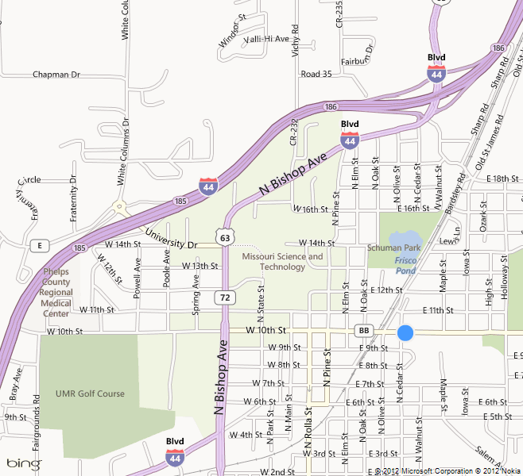

    - Missouri s&T Map Legend & Main Campus
**The S&T campus landscape is changing significantly**
The changes to the map are reflected in red in the index.
An updated map is being created with the changes noted. It will be added to this plan upon its completion.

CLASSROOMS/LABS
- James E. Bertelsmeyer Hall
- Butler-Carlton Civil Engineering Hall
- Computer Science Building
- Emerson Electric Company Hall
- Engineering Management Building
- Fulton Hall
- Gale Bullman Multi-Purpose Building
- Harris Hall
- Humanities and Social Sciences Building
- IDE Building
- V.H. McNutt Hall
- Physics Building
- Pine Building
- Rock Mechanics and Explosive Research Center
- Rolla Building
- Schrenk Hall
- Toomey Hall

RESEARCH/SUPPORT FACILITIES
- Engineering Research Laboratory
- MSTR
- Technology Development Center
- Straumanis-James Hall
- Curtis Laws Wilson Library

STUDENT HOUSING
- Altman Hall
- Farrar Hall
- Miner Village
- Residential Commons 1
- Residential Commons 2
- Residential Life and Dining Services
- Rolla Suites Building 2
- University Commons
- Thomas Jefferson Residence Hall

CAMPUS/STUDENT SUPPORT
- Veteran’s Resource Center has been relocated to Harris Hall
- Regional Professional Developmental Center
- Allgood-Bailey Stadium
- Athletic Fields
- S&T Police and Parking
- Campus Support Facility (Removed)
- Castleman Hall
- Centennial Hall
- Chancellor’s Residence
- Custodial and Landscape Service Building
- Fitness Center
- General Services Building (now on Spruce Drive west of Fraternity Drive – former intramural rugby fields)
- Hasselmann Alumni House (Miner Alumni Association)
- Havener Center
- Kummer Student Design Center
- Miner Dome Indoor Practice Facility
- Norwood Hall
- Parker Hall
- Power Plant (Removed)
- Little Miners Childcare Center
- Student Diversity, Outreach, and Women’s Programs Center
- Student Health Complex
- Student Recreation Center
- Temporary Facility A

CAMPUS LANDMARKS
- E3 Commons
- EcoVillage
- Millennium Arch
- Observatory
- The Puck
- Solar Village
- Stonehenge

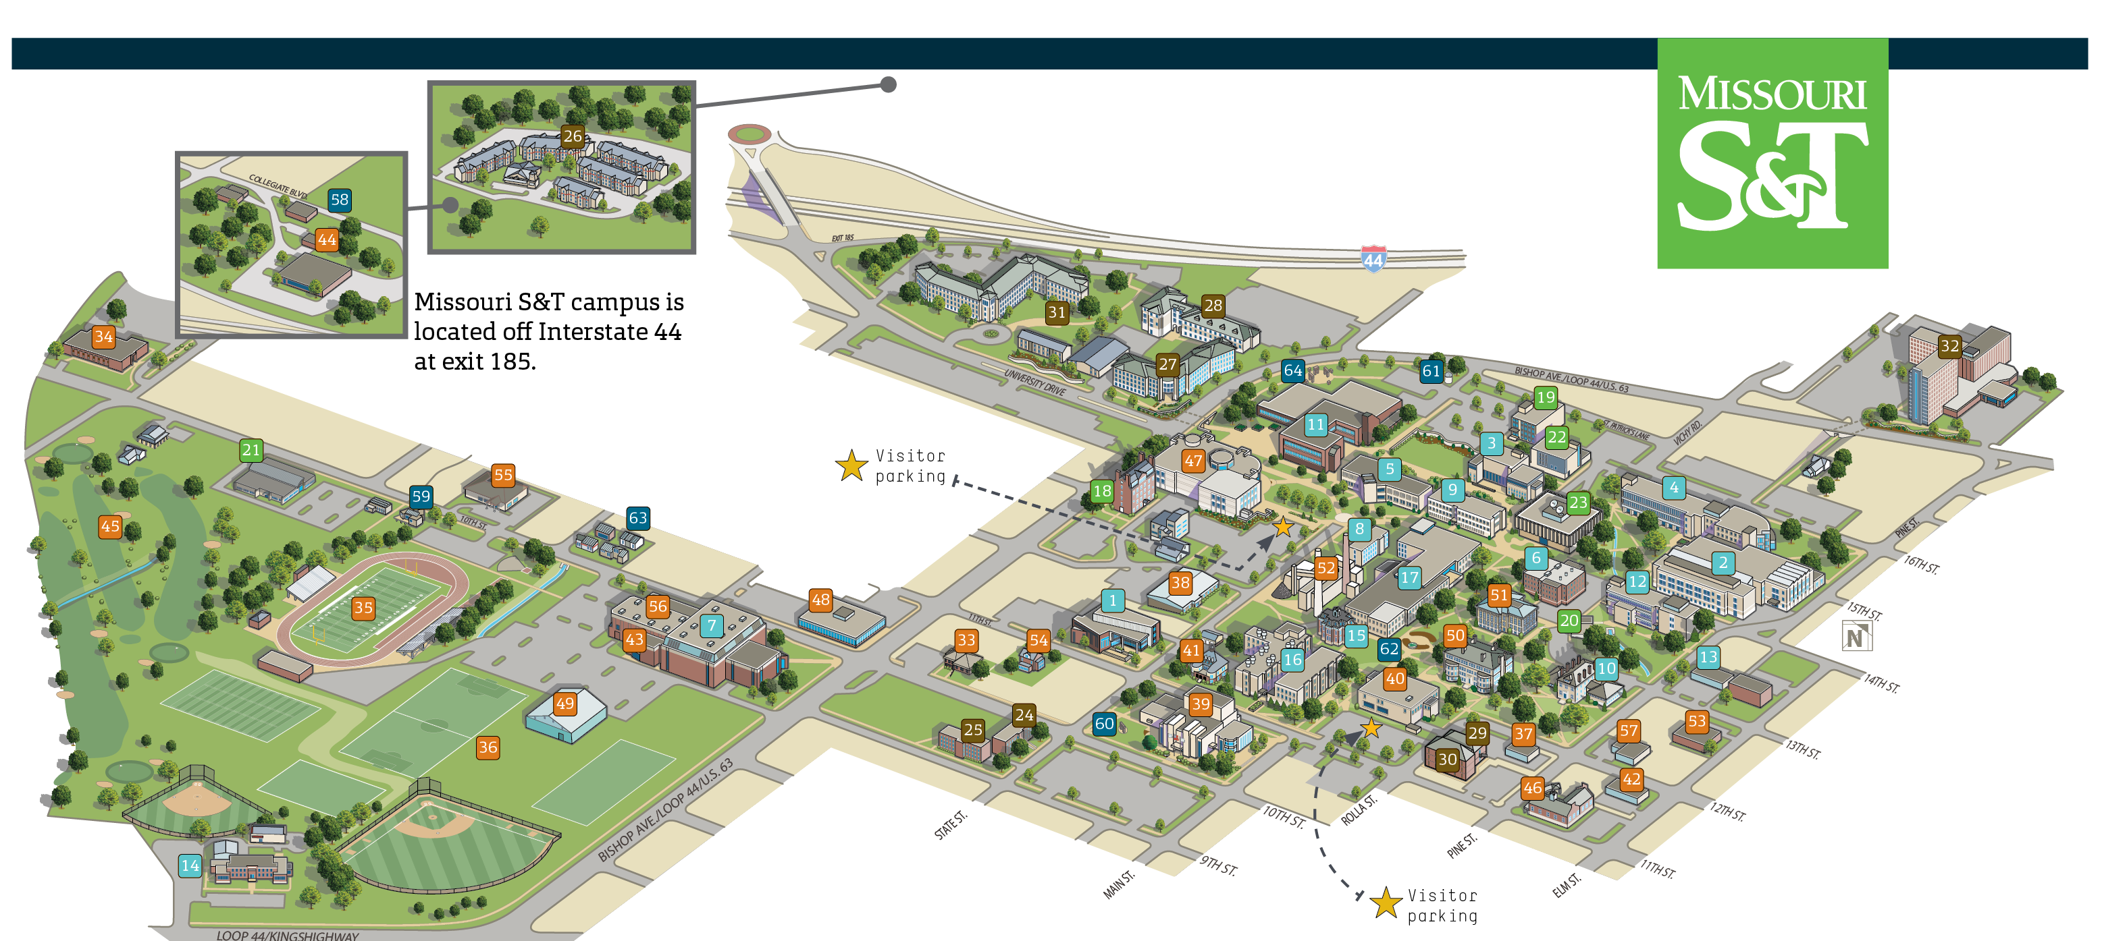

    - Lecoma Tower
205 County Road 5430, Lecoma, MO

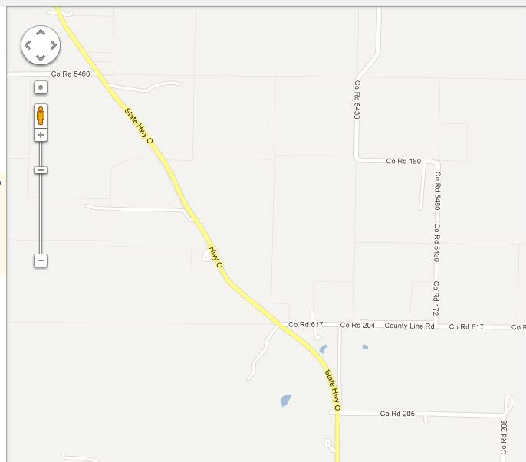

    - Hypoint Industrial Park
4000 Enterprise Drive, Rolla, MO

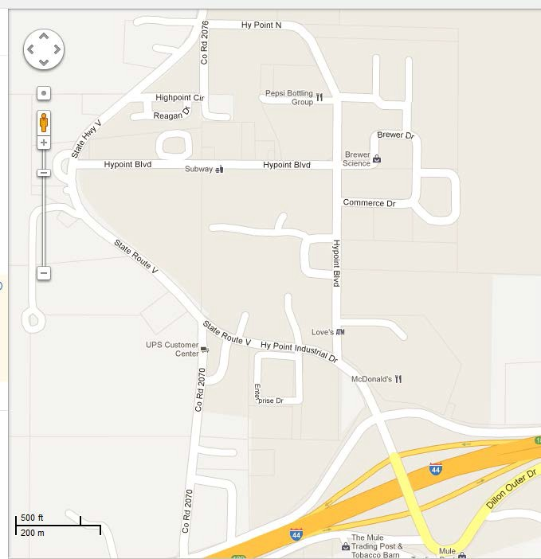

    - Experimental Mine
12350 Spencer Road, Rolla, MO

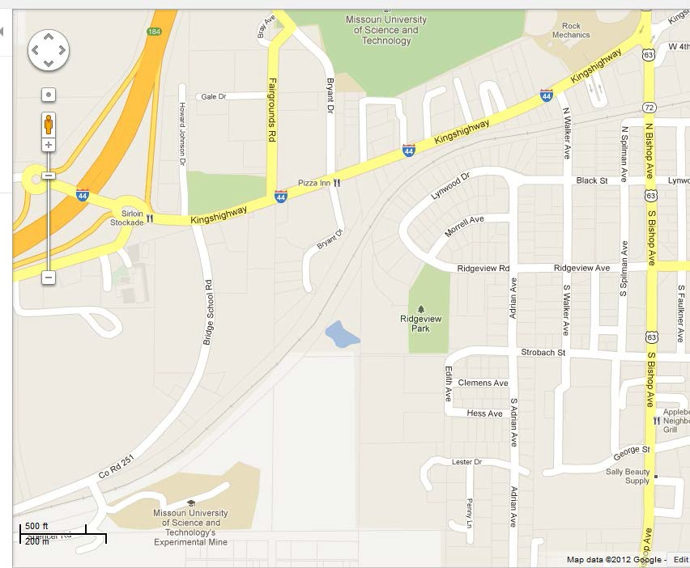

HAZARD SPECIFIC AND CAMPUS SPECIFIC EMERGENCY RESPONSE PLANS

5.0 Hazard Specific Emergency Response Plans

  - Active Shooter.
In the event of an active shooter incident, notification messages will be distributed through text, radio, e-mail, verbally and/or the campus web site. If it is safe to do so, leave the campus immediately! When it is safe to return to campus, “all-clear” messages will again be distributed through text, radio, e-mail, verbally, and/or the campus web site. The following guidelines are not all inclusive but may increase your chances of surviving an active shooter incident.

    - What to report:
Your name
Location of the incident (be as specific as possible) Number of assailants
Identification or physical description of assailants (race, gender, clothing, type of weapons, etc.)
Injuries (number injured, type of injuries) Your location (building and room number) DO NOT hang up until the Dispatcher does.

    - In the Classroom or Office:
Remember the concept of Run-Hide-Fight.
If you can safely leave the classroom or office, do so. Proceed to a location away from the situation and contact law enforcement. If you cannot leave the classroom or office, lock and barricade all room entrances. Turn off the lights in the room, close the blinds, and stay calm. Remain out of sight and silence your cell phone. If you unable to run, and hiding is not an option, you may have to fight. Use any available object as a tool to protect yourself. Fighting should be the last option. If confronted by the police, follow their directions exactly. Follow the instructions in the mass notification message and inform others that are nearby.

    - In Hallways or Corridors:
Remember the concept of Run-Hide-Fight.
If you are in a hallway and can safely leave the building, do so. If you cannot safely leave the building, proceed to the closest office or classroom and secure the room by locking and barricading all room entrances. Turn off the lights in the room, close the blinds, and stay calm. Remain out of sight and silence your cell phone. If you unable to run, and hiding is not an option, you may have to fight. Use any available object as a tool to protect yourself. Fighting should be the last option. If confronted by the police, follow their directions exactly. Follow the instructions in the mass notification message and inform others that are nearby.

    - Large Rooms or Auditoriums:
Remember the concept of Run-Hide-Fight.
If you are in a hallway and can safely leave the building, do so. If you cannot safely leave the building, proceed to the closest office or classroom and secure the room by locking and barricading all room entrances. Turn off the lights in the room, close the blinds, and stay calm. Remain out of sight and silence your cell phone. If you unable to run, and hiding is not an option, you may have to fight. Use any available object as a tool to protect yourself. Fighting should be the last option. If confronted by the police, follow their directions exactly. Follow the instructions in the mass notification message and inform others that are nearby.

    - Open Spaces:
Remember the concept of Run-Hide-Fight.
Stay alert and follow instructions given in the mass notification message. Avoid the area noted in the alert, proceed to a safe location and await further instructions from law enforcement or campus officials. Consider the difference between cover and concealment. Cover protects you from gunfire, while concealment merely hides you from the attacker. Strive for cover and concealment if you are unable to flee the incident.

    - Un-securing a location:
Consider risks before un-securing rooms. The shooter may be trying to enter the room.
Consider the safety of those secured inside the room versus those outside the room.

    - Trapped with the Gunman:
If you are trapped with the gunman, don’t do anything to provoke them. If the gunman is not shooting and he tells you to do something, only you can draw the line on what you will or will not do to preserve your life or the lives of others.

If the gunman does start shooting people, you need to make a choice. At this point it is your choice. You can stay still and hope he doesn’t shoot you; run for an exit while zigzagging in an attempt to escape; or even attack the shooter. Attacking the shooter is very dangerous, but certainly no more than doing nothing and dying in place. A moving target is much harder to hit than a stationary one and the last thing the shooter will expect is to be attacked by an unarmed person. Any option chosen may still result in injury or death.

5.12 Evacuation Guidelines.
In advance of an emergency, know your exit options, identify the
closest exit to your current location and the fastest route to that
exit. In the event of an emergency, if you are told to Run-Hide-
Fight, disregard your personal items and follow the instructions in
the mass notification message to stay safe and inform others that
are nearby.

5.12.1 Evacuation from a Building:
A. Proceed as quickly and safely as possible through the nearest
exit and remain calm.
B. Avoid using elevators during emergencies.
C. Gather in an area away from the emergency.
D. Notify family and friends to let them know you are safe.
E. Do not re-enter the building until law enforcement or campus
Representatives inform you it is safe to return.

5.12.2 Shelter in place versus Secure in Place:
In some instances, you may be instructed to shelter in place or secure in place. Scenarios involving shelter in place would likely surround an impending weather emergency or some type of chemical release or leak. Other instances would include smoke or flames outside your room, electrical wires blocking your exit, or you have a disability that makes it difficult/impossible for you to evacuate. In those cases, attempt to notify emergency personnel (via 911) to report the fact that you are sheltering in place and why you are sheltering in place. Give your exact location and follow the instructions given by the dispatcher.

Securing in place would entail a response to an emergency requiring you to secure the room that you are occupying by locking and barricading all room exits. Remain in the room until given further instructions via the mass notification message, campus alert, first responders, or University leadership.

  - Bomb Threat.

    - Suspicious Package/Object:
If you receive or discover a suspicious package or foreign device: Do not touch it or move it. Immediately dial 911. Evacuate all people from the room or immediate area. Following are means for identifying a possible letter or package bomb:
      - Restrictive markings such as "confidential" or "personal"
      - Excessive postage
      - Handwritten or poorly typed address
      - Incorrect titles
      - Misspellings of common words
      - Oily stains or discolorations on package
      - Excessive weight
      - Rigid, lopsided or uneven envelopes
      - Protruding wires or tinfoil
      - Excessive tape or string
      - No return address

    - Oral or Written Bomb Threat:
- Record date and time of call or receipt of message. Note the number of the call.
- Take the caller seriously
- Have a co-worker call 911 on another line, or call the number yourself immediately after hanging up
- Do not hang up! Try to keep the caller talking as long as possible to determine the information on the Bomb Threat Checklist
- Missouri S&T Police will make the decision on whether a building evacuation is warranted. The decision should be made after consultation with the Department Chair overseeing the building. If evacuation of the building occurs, exit the building immediately and stay at a distance of 500 feet or about the length of two football fields.

5.2.2.1 Bomb Threat Checklist

Ask:

When is the bomb going to explode?

Where is it right now? (note if caller knows area by their description)

What does it look like?

What kind of bomb is it?

What will cause it to explode?

Did you place the bomb? Why?

What is your address?

What is your name?

Exact wording of threats:

Caller’s Phone Number? (Note if you have a display phone)

Male/Female

Approx. Age:

Caller’s Voice:

Calm | Nasal | Slow | Raspy | Loud
Angry | Stutter | Excited | Rapid | Deep
Soft | Laughter | Normal | Deep
Disguised | Crying | Accent | Slurred | Lisp
Familiar

Background Sounds:
Street Noises Factory Machinery
Animal Noises Other Voices
Static Music
Motor/ Office Machinery

Additional Comments:

  - Civil Disorders/Disturbance.
Campus demonstrations must be peaceful and non-obstructive. A demonstration that interferes with normal operations of the university; or prevents or impedes access to a university facility; or threatens physical harm to a person or damage to university property; or endangers the safety of a person; or in any way disrupts the learning environment of the university may be required to cease the disruptive activity. The decision to terminate a demonstration will be made by the Chancellor or his/her designee. The demonstrators will be informed that their actions are in violation of university rules and/or criminal law. The demonstrators will be given a deadline to terminate the demonstration and informed that if they fail to terminate the demonstration, they will be subject to university disciplinary action and/or arrest. Those remaining after the deadline will be subject to arrest. Removal of the demonstrators will be in accordance with police department policy on use of force. Efforts should be made to photograph/video record the incident to ensure detailed documentation of the incident.
  - Earthquake.

    - If Inside:
- Stay inside.
- Seek cover immediately. Take cover underneath a desk or table. Move against an interior wall and kneel or sit. Protect your head and neck. Do not seek cover under laboratory tables or benches as chemicals could spill on you.
- Stay away from windows and objects that could fall on you.

- Persons with wheelchairs should lock brakes.
- Do not use elevators.

    - If Outside:
- Stay outside.
- Move into an open area away from trees, buildings, walls, and power lines.
- Drop to your knees and get into a fetal position, close your eyes and cross your arms over the back of your neck for protection.
- Stay in a fetal position until the shaking stops.

    - After Shaking Stops:
- Beware of broken glass, down electrical lines, unstable buildings and debris.
- Do not use regular or cellular telephones except to report serious injuries.
- Evacuate the building is you are able to do so.
- Attempt to determine who is missing or possibly still in the building.
- Do not enter any building.
- Aftershocks may occur hours, days, or weeks after the quake. Remain alert and be prepared to seek a safe location again.

  - Fire.

    - If You Discover a Fire on Your Floor:
- Activate the fire alarm system.
- Evacuate the building if able, using the most efficient escape route. Close doors behind you, but do not lock the doors. (DO NOT USE ELEVATOR!)
- Call 911

    - Once a Fire Alarm is Activated:
- Evacuate using the nearest exit. (DO NOT USE ELEVATOR!)
- Assist persons with special needs if able to.
- Notify Police Department personnel or fire personnel if you know or suspect someone is trapped inside the building.
- Gather outside at a designated assembly area, and do not attempt to re-enter the building until instructed to do so by Police Department or Fire Department personnel.

    - If Trapped in a Room:
- Place wet cloth material around or under the door to prevent smoke from entering the room.
- Close as many doors as possible between you and the fire.
- Hang something from the window to let fire personnel know you are there. Or try to signal someone outside. DO NOT

BREAK GLASS until absolutely necessary (outside smoke may be drawn into room).
- Call 911

    - If Caught in Smoke:
- Drop to hands and knees and crawl toward exit. Stay low as smoke will rise.
- Cover your mouth with a wet cloth and breathe shallowly thru nose.
- Hold your breath as much as possible.

    - Using a Fire Extinguisher:
If you have been trained and it is safe to do so, you may fight small fires with a fire extinguisher. Never use water on an electrical or flammable liquid fire. Use a dry chemical or carbon dioxide extinguisher only and stay back a minimum of 10 feet.

Fire Extinguisher Instructions:
- Pull safety pin from handle.
- Aim at base of fire.
- Squeeze the trigger handle.
- Sweep from side to side at base of fire.

  - Hazardous Material:

    - Major Hazardous Spill or Leak:
- Do not attempt to clean up the spill yourself!
- Immediately inform everybody in the area to leave the area and close doors behind you.
- Activate the nearest fire alarm.
- Call 911.
- Provide the dispatcher with information concerning injuries, type of chemicals, flammability, etc.
- Provide clean-up/rescue personnel with appropriate Materials Safety Data Sheets (MSDS) and other pertinent information.

    - Minor Hazardous Spill or Leak:
- Attempt to contain the spill using absorbent material. DO NOT ALLOW ANYTHING TO LEAK INTO DRAINS!
- Wear proper personal protective equipment while cleaning up.
- Notify Environmental Health and Safety at 573-341-4305 or the Missouri S&T Police Department at 573-341-4300

    - If the chemical comes into contact with any person:
- Remove all contaminated clothing
- If there is contact with a person’s eyes, rinse eyes with water for at least 15 minutes.
- If there is contact with a person’s skin, thoroughly rinse under water and then wash with soap and water.

    - Radiological:
- Call 911and give details about the emergency.
- Follow the University’s radiation emergency protocol as posted in the area.
- Remember to prevent the spread of contamination, DO NOT leave the area and limit movement until those affected can be determined, evacuating those not affected.
- DO NOT attempt to clean up any radioactive spill on your own without permission of the Radiation Safety Office.

  - Medical Emergency:
All University community members are encouraged to learn first aid and CPR (The University Police will provide training if requested). If you discover a medical emergency:
      - Avoid leaving the injured/ill person except to summon help
      - If injury/illness is severe or life-threatening dial 911.
      - Do not move person unless he/she is in danger.
      - Render first aid or CPR if trained and qualified.
      - If you are exposed to another person’s bodily fluids, inform Police Department personnel when they arrive.

  - Severe Weather:

    - Severe Thunderstorm Watch:
Conditions are right for a severe thunderstorm. Continue with normal activities but continue to monitor the situation.

    - Severe Thunderstorm Warning:
Severe thunderstorms are occurring. Be prepared to move to a place of shelter if threatening weather approaches. Remain indoors and away from windows until the severe storm passes. If large hail begins to fall, seek immediate shelter.

    - Tornado Watch:
Conditions are right for a tornado. You should keep alert by listening to radio, television or weather radio for the latest weather information. Be prepared to take cover should the weather change or a warning is issued.

    - Tornado Warning:
This means a tornado has been sighted or indicated by radar. People in the path of the storm should take immediate lifesaving actions. The Rolla Police Department will activate the city’s outdoor sirens. Outdoor sirens are used only as an attention getting device. When warning sirens sound:

    - Procedures:
Know the location of the nearest emergency shelter for your location. Specific information regarding the actual nature of the emergency will be broadcast by local media. Following are some radio stations that serve the area in broadcasting local emergency information:

KZNN 105.3FM
KTTR 1490 AM/99.7 FM KMNR 89.7 FM
KDAA (SAM) 103.1 FM KKID 92.9 FM

Seek shelter, preferably in a designated area. If that is not available seek shelter in a basement or below-ground location. If a basement or below ground location is not available, seek shelter at the lowest floor. Move to an interior hallway, under a stairwell, or a center room with no windows. Stay away from auditoriums, gymnasiums, or areas with a wide free span roof.

Stay away from outside walls, exterior doors and glass windows or partitions. Do not open windows.

Take cover under heavy furniture. Crouch as low as possible to the floor, facing down, and cover your head with your hands. Try to cover yourself with some sort of protection such as a blanket or mattress.

If in a vehicle, get out and seek shelter in a nearby well-built structure. If you cannot find a well-built structure nearby, seek out a ditch or ravine, which can offer some protection. Lay prone; face down, with your hands covering your head.

Check local radio and television stations concerning the tornado warning.

There is NO all clear message sounded through the siren system. It is recommended that community members monitor local media sources or a weather radio during the storm so they will know when the threat has expired.

After the all clear, leave badly damaged buildings, if it is safe to do so. Do not use elevators as they may be damaged. If you are surrounded by debris, be aware that removing some of it can cause other debris or part of the building to collapse. If it is not safe or possible to leave the area, stay there until assisted out. Beware of hanging or downed electrical lines inside and outside. Do not attempt to return to a building unless directed to do so by Police

Department personnel. Do not attempt to turn on or off any utilities or other equipment.

  - Structural Collapse:

If you are in a building that has collapsed or experienced a severe structural damage, try to evacuate the building. Do not use elevators. Choose an alternative exit route if you encounter building damage. If you cannot exit the building, go to an undamaged portion of the building and try to signal for help. If you are outside the building, do not enter the building. Proceed to a safe location away from the damaged building.

  - Utility Failure:

    - To report a localized power outage or water leak, call Physical Facilities at 573-341-4252. If it is after normal business hours call the Missouri S&T Police Department at 573-341-4300.

    - Major Power Outage:
- Remain calm.
- Follow directions from Police Department personnel.
- Laboratory personnel should secure all experiments and unplug electrical equipment prior to evacuating. All chemicals should be stored in their original locations. Provide natural ventilation by opening all windows and/or doors if outside temperatures are above 45 degrees. If this is not possible, or natural ventilation is inadequate, evacuate the laboratory until the power is returned.
- Do not light candles or other type of flame for lighting.
- Unplug all electrical equipment (including computers) and turn off light switches.
- Some building’s emergency lighting power source is provided by battery and will have a limited amount of time the emergency lighting remains on. In this instance, you should evacuate the building immediately when the emergency lighting comes on. This is especially important if there is limited or no natural lighting available.

    - Trapped in an Elevator:
- If you are trapped in an elevator, use the elevator’s emergency phone to notify the Police Department. If there is no emergency phone in the elevator, trigger the elevator’s emergency alarm button.

- If you become aware that people are trapped in an elevator, tell passengers to stay calm and that you are getting help. Instruct passengers to pick up emergency phone or push the emergency button in elevator so they can provide direct

information to the emergency responders. Or call 911 and provide information.

    - Water Leaks/Flooding
In the event of water leaks, try to contain the leakage in a container to minimize damage or safety hazards. If it is a significant water leak, avoid the areas where water has accumulated, and wait for help. Water makes an excellent conductor of electricity; thus electric shock is a strong possibility.

    - Gas Leak
If you discover a gas leak:
- Cease all operations.
- Call 911.
- Evacuate the area.
- Do not switch lights or electrical equipment on or off.

  - Violent or Criminal Behavior

    - Missouri S&T strives to provide a safe and secure work environment for all employees. Toward this end, intimidation, threats and acts of violence, with or without the presence of a weapon, will not be tolerated. Individuals found to engage in behavior in violation of this policy will be subject to discipline up to and including termination.

Employees, who are the victims of violence, believe they may be the recipients of violence, or who have knowledge of potential violence against others, are encouraged to promptly notify an appropriate administrator, University Police Department and/or Human Resources, Affirmative Action, Diversity & Inclusion Department.

    - Hostage situation
In the event of a hostile action against personnel or a facility at Missouri University of Science and Technology call 911. If possible, evacuate the area where the event is taking place. Make careful mental notes of as much factual information as possible.
This should include information like:
      - Location of incident.
      - Number and identity of hostages or perpetrators.
      - Type and number of weapons or communications devices that are apparent.
      - As much descriptive information as possible concerning the perpetrators.

    - Individuals with Mental Health Issues
A person whose behavior has become threatening, disruptive, or violent requires a different kind of approach. A very small number of people become aggressive when they are extremely frustrated by a situation that seems beyond their control. Although most individuals

rarely become violent, it does occur, and it is important to know how to respond. Here are some guidelines:

If You Feel Uneasy About an Individual’s Behavior:
- Respect your feelings of unease and discuss them with a colleague, your Department Chair, administrator, consult with the Counseling Center or speak with a police officer.
- Meet with the individual and ask him/her to change the behaviors that are causing a problem. Make sure that other staff or faculty members are nearby when you meet with the individual.
- Refer the individual for help with whatever might be causing the problem (e.g. stress, learning difficulties, or personal problems)

If a Threatening or Violent Situation Occurs During Class:
- Ask the student to accompany you to discuss the situation where help is available.
- Avoid being alone or isolated with the student.
- Seek help from the University Police and/or consult with the Counseling Center staff as needed.

If You are Alone with an Angry, Verbally Abusive, or Physically Threatening Person:
- Calmly tell the person that verbally abusive behavior is unacceptable (e.g. “When you yell at me, I find it hard to listen to you.”)
- Avoid arguing, shouting, becoming hostile or threatening (e.g. “I’ll have you expelled from school,” or “I'll have you fired.”)
- Don’t touch the person.
- Leave the situation if possible.
- Call 911

If in doubt with any situation call 911.

  - Evacuation Guidelines
In advance of an emergency, determine the nearest exit to your location and the best route to follow. If time permits during evacuation, secure your workplace and take personal items. In most emergencies, complete evacuation of the campus is not necessary. If, however, there is a major hazardous materials release, fire, or other major incident, it may be necessary to relocate all University personnel to a safer location.

    - Evacuations From a Building:
- Walk, do not run.
- Do not use elevators.
- Close but do not lock doors.
- Turn off electronics including computers. Take personal belongings if time permits.

- If safe to do so, assist people with special needs as indicated by that person. If unable to assist call 911to request assistance.
- Gather outside at a designated staging area and try to account for all personnel.
- If you cannot return to your building, wait for instructions from Police Department personnel.

    - “In Place” Evacuations:
In some instances, it is safer to evacuate “in place” than it is to leave a building, e.g., smoke or fire is immediately outside your room; live electrical wires bar access to the exit; or individuals with mobility disabilities are on upper or below ground floors.
- If safe to do so, go to the nearest stairwell and tell someone who is evacuating to notify emergency personnel of your location and that you are unable to evacuate the building.
- Or call 911 and tell them your name, your location, that you are unable to evacuate, and why you are unable to evacuate the building.
- Follow directions of the 911 dispatcher.

    - Person with Disabilities Evacuation
      - General Guidelines

        - Faculty, staff, students, and visitors with disabilities should develop their own facilities’ evacuation plans and identify their primary and secondary evacuation routes from each building they use.
        - You should ask individual(s) from the building to become an evacuation assistant. The individual(s) should be willing to assist you in case of an emergency. It is suggested that as many as three volunteers be available especially for those in a wheelchair.
        - Ask supervisors or instructors about evacuation plans for the buildings.
        - For an isolated and contained fire, a person with a disability may not have to evacuate. The decision to evacuate will be made by the Rolla City Fire Department (RFD). The RFD will tell the individual their decision or relay the information via the University Police.

      - Evacuation Options
        - Mobility Impaired - Wheelchair
Persons using wheelchairs should stay in place or move to an area of refuge with their assistant when the alarm sounds. The evacuation assistant should tell RFD or University Police the location of the person with a disability. If the person with a disability is alone,

he/she should phone 911with their present location and the area of refuge they are headed too.

If the stair landing is chosen as the area of refuge, please note that many campus buildings have relatively small stair landings, and wheelchair users are advised to wait until the heavy traffic has passed before entering the stairway.

Stairway evacuation of wheelchair users should be conducted by trained professionals (RFD) if available. Only in situations of extreme danger should untrained people attempt to evacuate wheelchair users. Moving a wheelchair downstairs is never safe.
        - Mobility Impaired - Non-Wheelchair
Persons with mobility impairments, who are able to walk independently, may be able to negotiate stairs in an emergency with minor assistance. If danger is imminent, the individual should wait until the heavy traffic has cleared before attempting the stairs. If there is no immediate danger (detectable smoke, fire, or unusual odor), the person with a disability may choose to stay in the building, using the other options, until the emergency personnel arrive and determine if evacuation is necessary.
        - Hearing Impaired
Some buildings on campus are equipped with fire alarm strobe lights; however, many are not. Persons with hearing impairments may not hear audio emergency alarms and will need to be alerted of emergency situations. Emergency instructions can be given by writing a short explicit note to evacuate.
        - Visually Impaired
Most people with a visual impairment will be familiar with their immediate surroundings and frequently traveled routes. Since the emergency evacuation route is likely different from the commonly traveled route, persons who are visually impaired may need assistance in evacuating. The evacuation assistant should offer their elbow to the individual with a visual impairment and guide him or her through the evacuation route. The evacuation assistant should communicate to the impaired person as necessary to assure safe evacuation.

  - Emergency Procedures Poster is displayed in all campus buildings. It is a quick guide to responding to various types of emergencies.

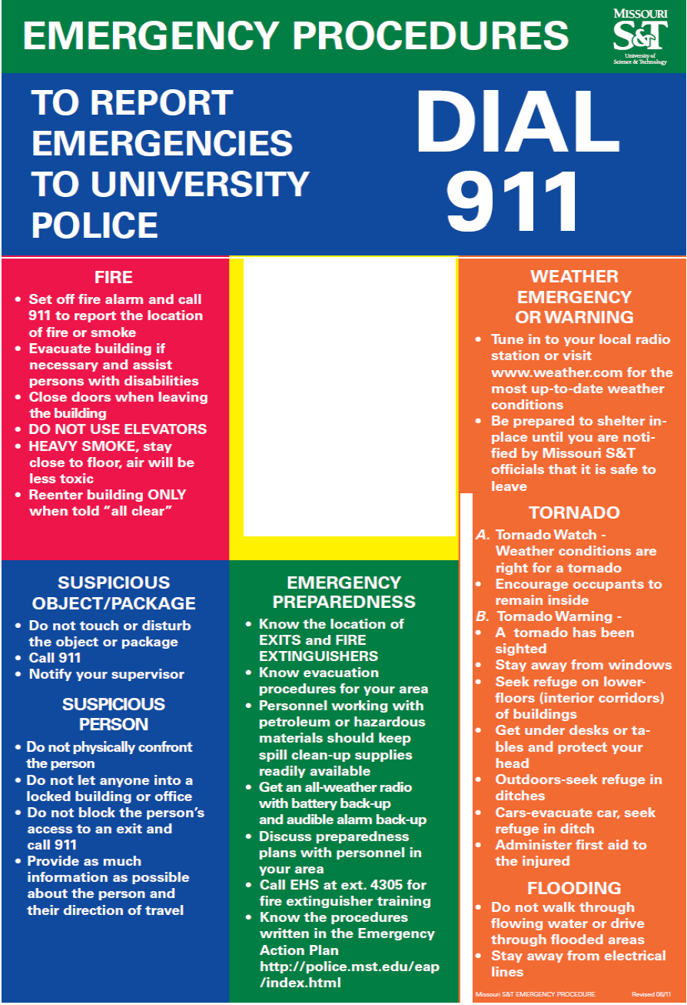

EVACUATION INFORMATION
    - Evacuate the building using the nearest exit (or alternate if nearest exitis blocked)
    - Do not use elevators
    - Take personal belongings (keys,purses.wallets.etc )
    - Secure any hazardous materials or equipment before leaving
    - Follow directions given by emergency personnel
    - Assist persons with disabilities

Campus-Specific Emergency Response Plans

  - Nuclear Reactor
The Missouri S&T Reactor has an emergency plan that is written and maintained in accordance with 10 CFR 50, Appendix E. Distribution of copies of that plan are made in accordance with the requirements of the Nuclear Regulatory Commission by the reactor manager.

Dangerous Materials Storage Facility
The Department of Environmental Health and Safety has an emergency plan for the Dangerous Material Storage Facility that is written and maintained in accordance with 40 CFR 264, section D. Distribution of copies of that plan are made in accordance with the requirements of that regulation.

ADMINISTRATIVE

7.0 Record of Distribution
Agency/Department | Title of Recipient | How Distributed (electronic or hard-copy)
Missouri S&T Chancellor | Chancellor’s Office | Hard Copy
Missouri S&T Academic Affairs | Provost’s Office | Hard Copy
Missouri S&T Finance and Admin. | Vice Chancellor’s Office | Hard Copy
Missouri S&T Student Affairs | Vice Chancellor’s Office | Hard Copy
Missouri S&T Univ. Title IX | Chief Diversity Officer | Hard Copy
Missouri S&T Strategic Comms | Executive Director of Communications | Hard Copy
Missouri S&T Human Resources | Director of Human Resources | Hard Copy
Missouri S&T Police Department | Police Chief | Hard Copy
Missouri S&T Police Department | Assistant Chief of Police | Hard Copy
Missouri S&T Police Department | Police Sergeant | Hard Copy
Missouri S&T Police Department | Police Sergeant | Hard Copy
Missouri S&T Police Department | Police Sergeant | Hard Copy
Missouri S&T Police Department | Clery Act Compliance and Accreditation | Hard Copy
Missouri S&T Police Department | Website | Electronic

8.0 Post-Incident Review and Recovery

  - Plan De-Activation
When deemed appropriate, the Incident Commander will initiate demobilization procedures. As part of that function, each response entity will forward copies of documents associated with its activities during the response to the Incident Commander. These documents should include any logs, status/activity sheets, photographs, financial records etc. related to the incident.

The Incident Commander should conduct an after-action analysis discussion of the incident involving key Emergency Operations Center personnel. Based on that analysis, the Incident Commander will ensure that an After-Action Report is completed on the incident. The After-Action Report will include a summary of the incident; an evaluation of the response; and recommendations for any changes to the Emergency Management Plan, staffing, equipment, training, etc. The After-Action Report will be submitted to the Chancellor for review and consideration.

  - Business Continuity/Recovery
In order to ensure that critical functions, systems and services continue in the event of an incident, it is imperative that business continuity plans be developed. A business continuity plan is a written document that generally consists of a brief description of the department including its critical processes; a phone tree of departmental personnel to include designated primary and secondary emergency response leaders; indicates vital records and or critical software/hardware needs; outlines recovery procedures for critical functions or workaround procedures; and identifies steps to mitigate the potential impact of an incident. Therefore, each department will have the responsibility to develop and maintain a business continuity plan for their area of responsibility to guard the university’s ability to efficiently recover from an incident.

Maintenance and Administration of the Plan

  - Program Administration

    - Maintenance
The Emergency Management Plan will be reviewed annually by all appropriate university officials. The Director, University Police will establish a schedule for the annual review of planning documents by those tasked in them. The plan will be updated based upon deficiencies identified during an actual incident or exercise; or when there are changes in threat hazards, resources and capabilities; or changes in the university organizational structure occur. Responsibility for revising or updating this plan is assigned to the Director, University Police.
The Director, University Police is also responsible for distributing these revised or updated plan documents in accordance with the current Record of Distribution section.

    - Revisions to Plan
Any recommendations for revision to the plan will be made to the Director, University Police. Those revisions requests will be reviewed for consideration for submission to the Chancellor for approval. Any revision approved by the Chancellor will be documented in the Records of Changes section and distributed.

  - Annual Plan Review and Hazard Vulnerability Assessment
The hazard vulnerability assessment will be carried out annually in conjunction with the annual review of the plan. The purpose of this review is to determine whether there have been any changes in the probability of occurrence or estimated impact of a particular hazard and whether any new potential hazards should be included. In addition to this annual review, an incident or exercise may indicate another review is warranted.

  - Exercises and Training
    - Exercises
At least once a year a test of the emergency management plan will be conducted. Both primary and secondary personnel will participate in at least one training exercise per year. Members of the Executive Policy Group will also be invited to attend the training exercise. The Director, University Police or Director of Environmental Health and Safety will supervise or coordinate the training.

    - Training
Every person designated as either having a primary or secondary incident command role to include members of the executive policy group will complete the Federal Emergency Management Agency’s IS 100HE course. A certificate of completion will be maintained in the member’s personnel file. It is the responsibility of the member’s supervisor to ensure completion of the required training.

List of Acronyms

CFR: Code of Federal Regulations CPR: Cardiopulmonary Resuscitation EOC: Emergency Operations Center
FEMA: Federal Emergency Management Agency

HRSAADI: Human Resources, Affirmative Action, Diversity & Inclusion ICS: Incident Command System

NIMS: National Incident Management System PIO: Public Information Officer
RFD: Rolla Fire Department

VC: Vice Chancellor

ANNEX A

EMERGENCY ACTION PLAN FOR
(Building Name)

Primary Building Emergency Coordinator

Contact Information Name: Department: Work Number:
Cell Phone Number:

Duties
Responsible for implementation and updating of plan.
Responsible for notification of building occupants of an emergency. Responsible for surveying persons at assembly points to try to determine if all occupants have exited the building and notify emergency personnel if it is suspected or known that someone is left in the building.
Meet emergency responders when they arrive at the building and notify them of the location of the incident, possible hazards, victims, etc.
Review the plan after each incident to determine whether changes or additions need to be made.

Secondary Building Emergency Coordinator

Contact Information Name: Department: Work Number:
Cell Phone Number:

Duties
Assist the Primary Emergency Building Coordinator during an incident
Assume all the responsibilities of the Primary Emergency Building Coordinator in their absence.

Department Contacts
Department (Name of Department in building) Primary Contact Name:
Work Number: Secondary Contact Name:
Work Number: Department (Name of Department in building)

Primary Contact Name:
Work Number: Secondary Contact Names:
Work Number:

Department (Name of Department in building) Primary Contact Name:
Work Number: Secondary Contact Name:
Work Number:

Department (Name of Department in building) Primary Contact Name:
Work Number: Secondary Contact Names:
Work Number:

Campus Emergency Contact

Missouri S&T Police Department | Emergency | 911
 | Non-emergency | 341-4300
Environmental Health and Safety | Business Hours | 341-4305
 | After Hours | 341-4300
Facilities Operations | Business Hours | 341-4252
 | After Hours | 341-4300

RESPONSE PROCEDURES FOR EMERGENCIES
NOTE: In all of the circumstances below, it is important to remain calm and follow steps as indicated.

Fire Emergencies

    - If you discover a fire, you should activate the Fire Alarm System.
    - From a safe location call the Fire Department (911). Given the nature and location of the fire. DO NOT HANG UP UNTIL 911 STAFF HAVE ALREADY HUNG UP!
    - Evacuate the building utilizing the escape routes outlined in this plan. You may collect valuables, i.e., purse, coats, etc., if within a reasonable reach and will not interfere with the evacuation of the building. Doors should be closed but not locked upon evacuating. DO NOT use elevators unless directed by emergency personnel.
    - If you come into contact with a student or visitor, you should direct them to evacuate the building. If you come into contact with an occupant who is disabled or having difficulty evacuating you should assist those individuals in evacuating the building, if doing so will not endanger the personal health or safety of yourself or the occupant needing assistance.
    - If you are trapped by smoke, stay low, cover your mouth with a wet cloth, stay near a window, open the window but do not break it, hang something out the window to let fire personnel know you are there and put something in cracks around the door, call 911 if possible.
    - Use a fire extinguisher, if feasible to do so without jeopardizing personal well- being.
      - Never use water on an electrical or flammable liquid fire. Use a dry chemical or carbon dioxide extinguisher only.
      - When using a dry chemical extinguisher on a flammable liquid fire, stay back a minimum of 10 feet from the fire.
        - Start at the leading edge of the fire and use a side-to-side sweeping action to extinguish the fire.
        - Remember the acronym P.A.S.S.
          - Pull the pin.
          - Aim at the base of the fire.
          - Squeeze the discharge handle.
          - Sweep from side to side.
    - If rescue duties are called for, the Fire Department will perform these duties. Please pay attention to the location and status of any person needing rescue and relay that information to the Building Emergency Coordinator who will notify the Fire Department Officer in Charge.
    - Once out of the building, gather at ENTER PRIMARY ASSEMBLY POINT to be surveyed. In the event that the primary assembly area is not safe or available, you should gather at ENTER SECONDARY ASSEMBLY POINT. Zone Monitors and/or the Building Emergency Coordinator will conduct a brief survey of all present to determine if anyone is potentially missing and/or possibly still in the building. You should not leave the assembly area, either to re-enter the building, go to another area of campus or leave the campus, until advised to do so by the Building Emergency Coordinator.
    - Report to your supervisor.

Medical Emergencies
    - If the individual is unconscious:
Call an ambulance (911). When reporting the emergency provide the following information:
      - Type of Emergency
      - Location of the victim
      - Condition of the victim
      - Any dangerous conditions
      - Do not move the individual unless authorized by some medical authority, or it is obvious that delay in movement would be detrimental to the individual.
    - If the individual is conscious:
Call for an ambulance (911) if requested by the individual. When reporting the emergency provide the following information:
      - Type of Emergency
      - Location of the Victim
      - Condition of the Victim
      - Any dangerous conditions
    - In all cases:
When an ambulance is called for, ask a fellow staff employee or the Building Emergency Coordinator to wait outside the building to flag the ambulance down and direct the emergency personnel to the location of the injured individual.
Notify appropriate supervisors.

Severe Weather
- HOW IS THE BUILDING NOTIFIED OF A SEVERE WEATHER WARNING (i.e. weather radio, mass notification system, internet, radio station, etc.)
OUTDOOR SIRENS ARE USED ONLY AS AN ATTENTION GETTING DEVICE WITH NO WAY TO DETERMINE WHY THE SIRENS ARE SOUNDING

Specific information regarding the actual nature of the emergency will be broadcast by the local media. Following are some radio stations that serve the area in broadcasting local emergency information:

KZNN 105.3FM KTTR 1490 AM/99.7 FM KDAA (SAM) 103.1 FMKKID 92.9 FM KUMR (SUNNY) 104.5 FM
No all-clear signal will be sounded; sirens are used only for warnings.
- HOW ARE THE OCCUPANTS OF THE BUILDING NOTIFIED OF A SEVERE WEATHER WARNING (i.e. phone calls, use of runners, mass notification system, e-mail, etc.)
- Once you have been notified of a thunderstorm warning, it is not necessary to take any additional steps other than to ensure that you are prepared if the conditions deteriorate.
- Upon notification of a Tornado Warning, take shelter.
If you are unable to seek shelter in one of the designated areas, move away from windows. Stay away from auditoriums, gymnasiums, areas having a wide, free span roof, or the upper levels of a building. Take cover under heavy furniture.
If you are outdoors and unable to access an indoor shelter, lie flat in the nearest depression, such as a ditch or ravine. If there is time, move away from the path of the Tornado at a right angle.
- If you come into contact with a student or visitor, you should direct them to take shelter in the building. If you come into contact with an occupant who is disabled or having difficulty taking shelter you should assist the individual in getting or taking shelter.
- After the danger has passed, you should report to the designated shelter/assembly point to allow the Building Emergency Coordinator to take a survey of all present to determine if anyone is potentially missing.

Hazardous Materials
- Evacuate the area to the extent appropriate.
- Warn fellow workers, supervisors, and the Building Emergency Coordinator.
- Call 911 if it is a major spill. If it is a minor spill, call Environmental Health and Safety (341-4305) during normal business hours; call the Missouri S&T Police (341-4300) if after hours, weekends, or holidays.
- Take action to contain the spill if it is possible to do so without jeopardizing personal safety or health.
- If it is warranted, evacuate according to the evacuation procedures outlined in this plan.
- If a medical emergency is created due to the hazardous material incident, then follow the procedures for Medical Emergencies and inform medical personnel that a hazardous materials incident has occurred, including the suspected type of hazardous material involved.
- DO NOT call state or national emergency response numbers without prior authorization.

Radiological
Fire Emergencies Involving Radiation:

- Follow the procedures for fire emergencies AND
- Inform emergency personnel that a radiation hazard may exist.

Medical Emergencies Involving Radiation:

- Follow the procedures for medical emergencies AND
- Inform medical personnel that a radiation hazard may exist.

Release of Radioactive Materials:

- Evacuate personnel from radiation contaminated area.
- Assemble all personnel in a nearby safe area until radiation surveys and personnel decontamination are performed by the Environmental Health and Safety Department.
- Prevent spread of contamination from the site.
- Use the nearest telephone for communication and avoid walking through buildings.
- Close off doors and windows and, if convenient, turn off air handling equipment that might transfer radiation contamination throughout the building.
- Control access to radiation area and place warning signs indicating radiation and contamination hazards.
- Contact Environmental Health and Safety (341-4305). At night, on weekends, or holidays call Missouri S&T Police (911).

Earthquake
- Earthquakes occur without warning. Some earthquakes are instantaneous tremors and others are significant sustained events followed by aftershocks.
- Stay indoors if already there.
- If indoors take cover. Suggested locations inside buildings that provide cover include:
Standing in a doorway and bracing your hands and feet against each side Getting under sturdy furniture, such as worktables or desks
Standing flat against an interior wall
DO NOT SEEK COVER UNDER LABROTORY TABLES OR BENCHES, CHEMICALS COULD SPILL AND CAUSE HARM
- Stay near the center of the building and avoid glass windows and doors.
- If outdoors, stay in open areas, away from buildings and structures, and a safe distance from utility wires.
- After tremors have stopped, gather valuables, if doing so will not jeopardize the personal health and safety of yourself and others, and quickly leave the building through the evacuation routes outlined in this Plan. DO NOT USE ELEVATORS.
- If you come into contact with a student or visitor, you should direct them to evacuate the building. If you come into contact with an occupant who is disabled or having difficulty evacuating, you should assist the individual in evacuating the building if doing so will not endanger the personal health and safety of yourself and the individual needing assistance.
- Once out of the building, gather at ENTER PRIMARY ASSEMBLY POINT to be surveyed. In the event that the primary assembly area is not safe or available, you should gather at ENTER SECONDARY ASSEMBLY POINT. Zone Monitors and/or the Building Emergency Coordinator will conduct a brief survey of all present to determine if anyone is potentially missing and/or possibly remains in the building. You should not leave the assembly area, either to re-enter the building, go to another part of campus or leave the campus, until advised to do so by the Building Emergency Coordinator.
- After tremors have stopped, stay away from damaged buildings and structures. Avoid going through or near buildings where there is a danger of falling debris.
- Be prepared for aftershocks. Although smaller than the main shock, aftershocks cause additional damage and may bring weakened structures down. Aftershocks can occur in the first hours, days, weeks, or even months after the quake.

Oral or Written Threat to People or Facilities, i.e., Bomb Threat

- Record time and date of call or receipt of message.
- Keep caller online as long as possible and attempt to determine the following:

When is the bomb going to explode?
Where is it right now? (note if caller knows area by their description) What does it look like?
What kind of bomb is it? What will cause it to explode?
Did you place the bomb? Why? What is your address?
What is your name? Exact wording of threats.
Caller’s Phone Number? (Note if you have a display phone) Male/Female
Race: _Approx. Age: _ Caller’s Voice:
Background Sounds:

- When the caller hangs up, call Missouri S&T Police (911) and report the above information.
- Notify your immediate supervisor and the Building Emergency Coordinator.
- A decision will be made on whether a building evacuation is warranted. If it is warranted, evacuation should take place as outlined in this plan.
- You should not touch any suspicious or unfamiliar objects. Do not conduct any type of search until police personnel arrive on scene.

Mechanical Equipment or Other Physical Facility Emergencies

- Call campus Facilities Operations (341-4252).
- Do not attempt to correct the mechanical emergency.
- If fire ensues, follow procedures outlined for a Fire Emergency.

PERSONS WHO NEED ASSISTANCE DURING AN EMERGENCY

  - In the event of any emergency there are occupants of the building who will need assistance in evacuating the building, taking shelter, taking cover, etc.
  - If you encounter someone who needs assistance during an emergency, you should attempt to assist the individual if it is possible to do so without jeopardizing the personal safety or health of yourself or the person needing assistance.
  - If you know or have reason to know that you will need assistance during an emergency, you should report that information to the Building Emergency Coordinator as soon as possible.
  - The following people are occupants of the building who have expressed the need for assistance in the event of an emergency to the Building Emergency Coordinator.

Known Persons Needing Assistance

Name: Department: Department Phone: Cell Phone:
Room:
Type of Assistance Needed:

Name: Department: Department Phone: Cell Phone:
Room:
Type of Assistance Needed:

Name: Department: Department Phone: Cell Phone:
Room:
Type of Assistance Needed:

